**Ex No: 7**

**Date:**

**EVALUATE EXPRESSION THAT TAKES DIGITS, *, + USING LEX AND YACC**

**AIM:**

To perform arithmetic operations that takes digits,*, + using lex and yacc.

**ALGORITHM:**

**Lex (exp7.l):**

1. Recognizes sequences of digits and returns the token NUMBER.
2. Ignores tabs and newlines.
3. Returns any other single character as itself.
4. Indicates the end of input with yywrap().

**Yacc (exp7.y):**

1. Includes headers and declares global variables.
2. Declares token NUMBER.
3. Defines operator precedence and associativity.
4. Defines grammar rules for arithmetic expressions.
5. Prints the result of the expression evaluation in the ArithmeticExpression rule.
6. Handles syntax errors with yyerror().
7. The main function, prompts for an arithmetic expression, parses it, and prints whether it's valid or not based on the presence of syntax errors.

**PROGRAM:**

**exp7.l:**

%{

#include<stdio.h>

#include "y.tab.h"

extern int yylval;

%}

%%

[0-9]+ {

       yylval=atoi(yytext);

       return NUMBER;

    }

[\t] ;

[\n] return 0;

. return yytext[0];

%%

int yywrap()

{

return 1;

}

**exp7.y:**

%{

#include<stdio.h>

int flag=0;

   int yylex();

void yyerror();

%}

%token NUMBER

%left '+' '-'

%left '*' '/' '%'

%left '(' ')'

%%

ArithmeticExpression: E{

      printf("\nResult=%d\n",$$);

      return 0;

     }

E:E'+'E {$$=$1+$3;}

 |E'-'E {$$=$1-$3;}

 |E'*'E {$$=$1*$3;}

 |E'/'E {$$=$1/$3;}

 |E'%'E {$$=$1%$3;}

 |'('E')' {$$=$2;}

 | NUMBER {$$=$1;}

;

%%

void main(){

   printf("\nEnter Any Arithmetic Expression which can have operations Addition, Subtraction, Multiplication, Divison, Modulus and Round brackets:\n");

   yyparse();

  if(flag==0)

   printf("\nEntered arithmetic expression is Valid\n\n");

}

void yyerror(){

   printf("\nEntered arithmetic expression is Invalid\n\n");

   flag=1;}

**OUTPUT:**

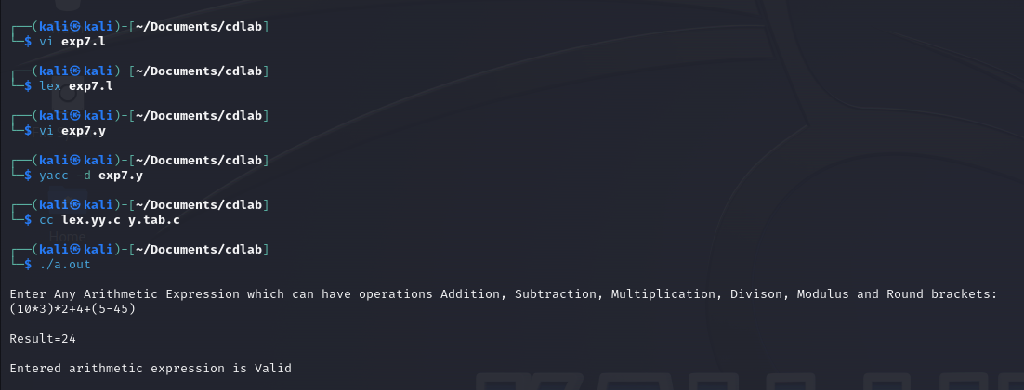

**RESULT:**

Thus, arithmetic operations that takes digits,*, + using lex and yacc have been performed.